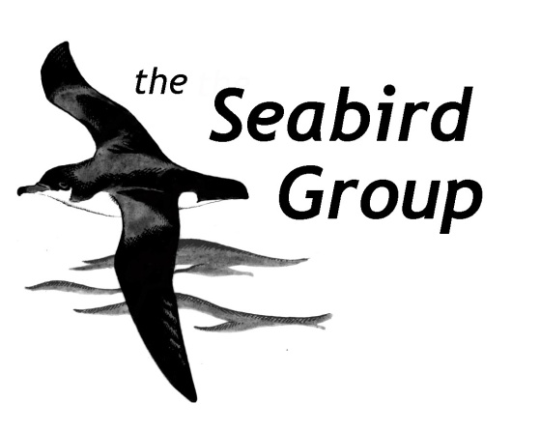

RESEARCH GRANT APPLICATION FORM

(June 2022 version)

Please ensure that you have read the Research Grants guidelines (available on our website) before filling the form. Please provide the fullest possible information to enable a complete assessment to be made of the proposed project.

Pre-review service
To help applicants with limited grant writing experience, we are trialling a pre-review service where one of our committee members (who will not take part in evaluating the grants in this round) will read and provide feedback on your application before you submit it for full review. If you wish to use this service please tick the box below and submit your grant 3 weeks before the deadline (i.e. 10 Oct or 7 Feb) to allow enough time for us to provide feedback and for you to edit the application accordingly. This is a free service.

I wish to use the pre-review service ☐

A – PERSONAL DETAILS
The details in this section (aside from questions 6 & 8) will not be shared with grant reviewers.

- Name of Applicant and/or Organisation:

- Address:

- Telephone number:

- E-mail address:

- Occupation/current position (e.g. undergraduate or PhD student, researcher, bird ringer…)

- Are you a Seabird Group member? YES / NO

- Diversity Monitoring
The Seabird Group is committed to promoting equality, diversity and inclusion within the seabird community, and aims to ensure fair and equitable representation and participation within our grants awards and other activities. All questions are optional: acceptance of your grant application will not be influenced by whether or not you choose to answer any or all of the questions. This information will remain confidential and will be used only to produce anonymised statistics on diversity and help The Seabird Group to monitor our inclusiveness as an organisation.
Ethnicity
Asian ☐
Black, African, Caribbean ☐
Latino, Hispanic ☐
White ☐
Other ☐
Prefer not to say ☐
Gender
Woman ☐
Man ☐
Other ☐
Prefer not to say ☐

Do you identify as a member of the LGBTQ+ community?
Yes ☐
No ☐
Prefer not to say ☐
Do you have a disability?
Yes ☐
No ☐
Prefer not to say ☐

- To increase inclusion of marginalised communities, we may choose to favour applicants from marginalised communities. Do you identify as part of a marginalised community? This information will be disclosed to grant reviewers.
Yes ☐
No ☐
Prefer not to say ☐

- Declaration:
I/We certify that all the information given on this form is to the best of my/our knowledge correct and I/We agree to abide by any requirements or conditions attached to any award of the grant by the Seabird Group.

Signature of Applicant (s):
Date:

B – GRANT PROPOSAL
- Title of the project:

- Description of Project (Max 800 words):
Include ALL of the following sections: background information, specific aims, details of methodology, likely timescale. Also provide a section discussing animal welfare considerations, detailing necessary permits and licences whether you have applied for or obtained them, as well as your relevant experience for conducting the proposed work. Additional information (e.g. past reports, examples of data) can be provided on a separate document.

- Total cost of project (please include a breakdown of costs: travel, subsistence, equipment etc):

- Amount of grant requested:

- Explain what the grant will be used for, and how important a contribution it will make to the full project:

- How are remaining costs being met (other grants, own contributions etc)? For other grants please give details (organisation, amount, year, whether awarded or pending):

Please e-mail this form (plus any attachments) as a single document with your name in the filename to the Secretary: secretary@seabirdgroup.org.uk . Outcomes will be given to applicants approximately 6 weeks after the round closes (i.e. around mid-December or mid-April).

