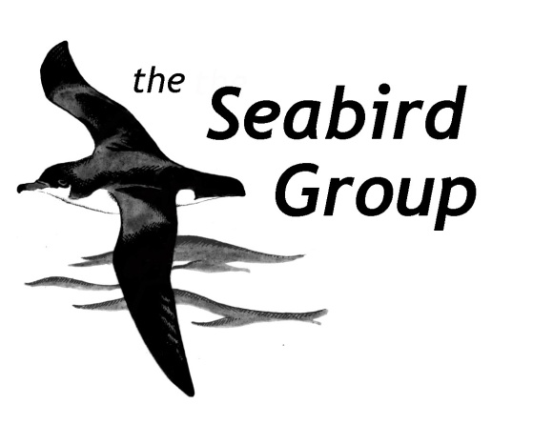

NATIONAL SEABIRD CENSUS GRANT APPLICATION FORM

The Seabirds Count national seabird census is currently underway, with 2021 the final year of surveying. Whilst a large proportion of sites have already been surveyed, there are still many gaps to cover to ensure the census is complete.

Grants to support seabird census projects for Seabirds Count are still available from the Seabird Group, from its census legacy fund. So far, successful census grant applications have ranged in amounts from £500 to £2700, although higher amounts may be considered. Census grant applications can be made at any time, there is no time deadline, but please apply as soon as possible, ready for 2021. If you have any questions or need information about setting up a census project for Seabirds Count, then please contact the Seabirds Count national coordinator, Daisy Burnell (seabirdscountcoordinator@jncc.org.uk), or the Seabird Group’s national census representative, Will Miles (seabirdcensus@seabirdgroup.org.uk).

NOTE: Before applying for this grant, please check with the Seabirds Count national coordinator (seabirdscountcoordinator@jncc.gov.uk) that your chosen site(s) are still in need of surveying, and when doing so please include a brief summary of your project plans.

To apply for a census grant from the Seabird Group:

Please ensure that the information below (points 1 to 12) is provided in full, so that a complete assessment of the proposed project can be made.

- Name of Applicant and/or Organisation:

- Address:

- Telephone number:

- E-mail address:

- Title of the project:

- Description of project (Max 800 words), including the following details:

- Name of site(s);
- Year that site(s) last surveyed (if known);
- All seabird species counts from the last survey (if known);
- Predicted duration of the surveys in 2021, including specific dates;
- Seabird species to be surveyed in 2021 (important: will ALL species at the site(s) be surveyed?);
- Methods to be used in 2021 (please give details, including whether the same Methodology will be used as for previous census surveys, and if not then the reasons why, and whether the surveys in 2021 will be made from land or a boat).

Data collected, including nil counts, must be entered into the SMP promptly after the survey has been completed, to allow for inclusion into the census analysis.

- Total cost of project (please include a rough breakdown of costs: travel, subsistence, equipment etc):

- Amount of grant requested:

- What specific parts of the project the grant will be used for:

- How are remaining costs being met (other grants, own contributions etc)? For other grants please give details (organisation, amount, year):

- Are you a Seabird Group member:

- Are you a student (if so, please supply details):

- Declaration:

I/We certify that all the information given on this form is to the best of my/our knowledge correct and I/We agree to abide by any requirements or conditions attached to any award of the grant by the Seabird Group.

Signature of Applicant (s):

Position (if applicable):

Date:

Please list any enclosures/ attachments:

Please e-mail the completed form (plus any attachments) to the Seabird Group secretary: secretary@seabirdgroup.org.uk

For official use only:
Date received:
Date circulated to committee:
Decision:

Amount awarded:

Date applicant informed of result of application:
Date summary report received:

